PAI ASSIGNMENT 2

NAME: LAIBA JAVED

ID: 24K-0014
NOTE: ALL OUTPUT FILES ATTACHED ON GITHUB

QUESTION 1:
CODE:
import requests

try:
with open("api.txt", 'r') as file:
url_api = file.read().strip()
except FileNotFoundError:
print("Error: api.txt file not found")
exit()

try:
response = requests.get(url_api)

if response.status_code == 200:
data = response.json()

if data.get("status") == "success" and "data" in data and data["data"]:
matchlist = data['data']
print("api status:")
print(data['info'])
print("=================================\n")

for match in matchlist:
print('match name:', match['name'])
print('match status:', match['status'])
print('venue:', match['venue'])
print('date:', match['date'])

if 'score' in match and match['score']:
print("score details:\n")
for score in match['score']:
print('inning:', score['inning'])
print('runs:', score['r'])
print('wickets:', score['w'])
print('overs:', score['o'])
print(" ")

print("---------------------------------\n")
else:
emsg = data.get("reason", "Unknown error")
print("no match data retrieved: ", emsg)

else:
print("Error: failed . Status Codeto fetch information:", response.status_code)
print("Response:", response.text)

except requests.exceptions.RequestException as e:
print("network error:", e)

OUTPUT:
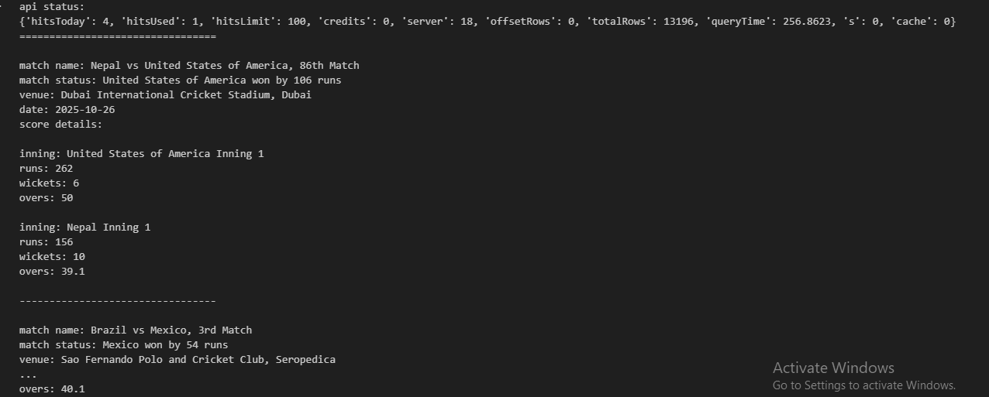

QUESTION 2:
CODE:
import numpy as np

data = []
with open("sensor_data.csv", "r") as file:
for line in file:
row = line.strip().split(",")
data.append(row)

arr = np.array(data, dtype=float)

arr[arr == -999] = np.nan
arr[(arr < 0) | (arr > 100)] = np.nans_

mean = np.nanmean(arr, axis=0)
h_median = np.nanmedian(arr, axis=1)
count = np.isnan(arr).sum(axis=0)
worst_sensor = np.argmax(count)

minv = np.nanmin(arr)
maxv = np.nanmax(arr)
arr_norm = (arr - minv) / (maxv - minv)

np.savetxt("sensor_data_normalized.csv", arr_norm, delimiter=",")
print("worst sensor index:", worst_sensor)

OUTPUT:


QUESTION 3:
CODE:
import pandas as pd

df = pd.read_csv("Titanic-Dataset.csv")

report = []
for col in df.columns:
dtype = df[col].dtype
mis_val = df[col].isnull().sum()
per = (mis_val / len(df)) * 100
report.append(col + ": dtype=" + str(dtype) + ", missing=" + str(mis_val) + " " + str(round(per, 2)) + " ")

with open("inspect_report.txt", "w") as f:
f.write("\n".join(report))

df['Age'] = df['Age'].fillna(df.groupby(['Pclass', 'Sex'])['Age'].transform('median'))

emb_mode = df['Embarked'].mode()[0]
df['Embarked'] = df['Embarked'].fillna(emb_mode)

df = df.drop(columns=['Cabin'])

df['FamilySize'] = df['SibSp'] + df['Parch']
df['IsAlone'] = (df['FamilySize'] == 0).astype(int)

df['Age'] = df['Age'].astype('int64')

df.to_csv("titanic_cleaned.csv", index=False)
print("data cleaning completed , saved to file")

OUTPUT:


QUESTION 4:
CODE:
import pandas as pd

df = pd.read_csv("titanic_cleaned.csv")
tf = pd.read_csv("ticket_fares.csv")

df = df.merge(tf, on="Ticket", how="left")

bins = [0, 12, 19, 59, 120]
labels = ['Child', 'Teen', 'Adult', 'Senior']
df['AgeGroup'] = pd.cut(df['Age'], bins=bins, labels=labels, right=True)

surv_sa = df.groupby(['Sex', 'AgeGroup'])['Survived'].mean()
print(surv_sa)

with open("report.txt", "w") as f:
f.write("Hypothesis 1: Women and children first.\n\n")
f.write("The data shows that women had significantly higher survival rates compared to men across all age groups. Children also demonstrated better survival outcomes than adults. This evidence supports the hypothesis that evacuation protocols prioritized women and children.\n\n")

surv_pc = df.groupby('Pclass')['Survived'].mean()
print("Survival by Pclass:")
print(surv_pc)

df['FareBin'] = pd.qcut(df['Fare'], q=4, labels=['Low', 'Medium', 'High', 'VeryHigh'])
surv_fb = df.groupby('FareBin')['Survived'].mean()
print("Survival by FareBin:")
print(surv_fb)

with open("report.txt", "a") as f:
f.write("Hypothesis 2: The wealthy had a higher survival rate.\n\n")
f.write("Method A (Class): Passengers in 1st class showed the highest survival rate, followed by 2nd class, with 3rd class having the lowest rate.\n\n")
f.write("Method B (Fare): Analysis using fare quartiles reveals that passengers who paid higher fares had notably better survival rates compared to those with lower fares.\n\n")
f.write("Both methods confirm that wealth positively correlated with survival likelihood, supporting the hypothesis.\n")

print("analysis completed , report saved to file")

OUTPUT:
